Lab 2 - Explore DNS Traffic

Mohamad Saiful Nizam Bin Abd Aziz (Apol)

A179830

Lab 2 - Explore DNS Traffic

# Objectives

Part 1: Capture DNS Traffic

Part 2: Explore DNS Query Traffic

Part 3: Explore DNS Response Traffic

# Background / Scenario

Wireshark is an open source packet capture and analysis tool. Wireshark gives a detailed breakdown of the network protocol stack. Wireshark allows you to filter traffic for network troubleshooting, investigate security issues, and analyze network protocols. Because Wireshark allows you to view the packet details, it can be used as a reconnaissance tool for an attacker.

In this lab, you will install Wireshark on a Windows system and use Wireshark to filter for DNS packets and view the details of both DNS query and response packets.

# Required Resources

* 1 Windows PC with internet access and Wireshark installed

# Instructions

## Capture DNS traffic.

* + 1. Open **Wireshark** and start a Wireshark capture by double clicking a network interface with traffic.

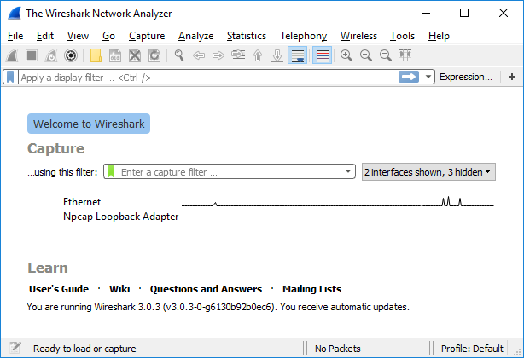

* + 1. At the Command Prompt, enter **ipconfig /flushdns** clear the DNS cache.

C:\Users\Student> **ipconfig /flushdns**

Windows IP Configuration

Successfully flushed the DNS Resolver Cache.

* + 1. Enter **nslookup** at the prompt to enter the nslookup interactive mode.
    2. Enter the domain name of a website. The domain name **www.cisco.com** is used in this example. Enter **www.cisco.com** at the > prompt.

C:\Users\Student> **nslookup**

Default Server: UnKnown

Address: 68.105.28.16

> **www.cisco.com**

Server: UnKnown

Address: 68.105.28.16

Non-authoritative answer:

Name: e2867.dsca.akamaiedge.net

Addresses: 2001:578:28:68d::b33

2001:578:28:685::b33

96.7.79.147

Aliases: www.cisco.com

www.cisco.com.akadns.net

wwwds.cisco.com.edgekey.net

wwwds.cisco.com.edgekey.net.globalredir.akadns.net

* + 1. Enter **exit** when finished to exit the nslookup interactive mode. Close the command prompt.
    2. Click **Stop capturing packets** to stop the Wireshark capture.

## Explore DNS Query Traffic

* + 1. Observe the traffic captured in the Wireshark Packet List pane. Enter **udp.port == 53** in the filter box and click the arrow (or press enter) to display only DNS packets.
    2. Select the DNS packet labeled **Standard query 0x0002 A www.cisco.com**.

In the Packet Details pane, notice this packet has Ethernet II, Internet Protocol Version 4, User Datagram Protocol and Domain Name System (query).

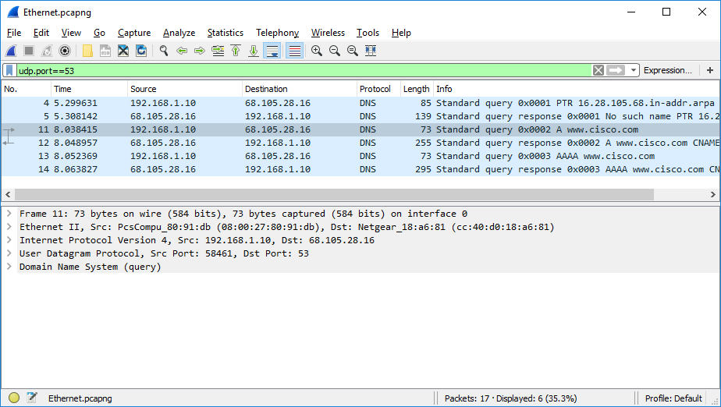

* + 1. Expand **Ethernet II** to view the details. Observe the source and destination fields.

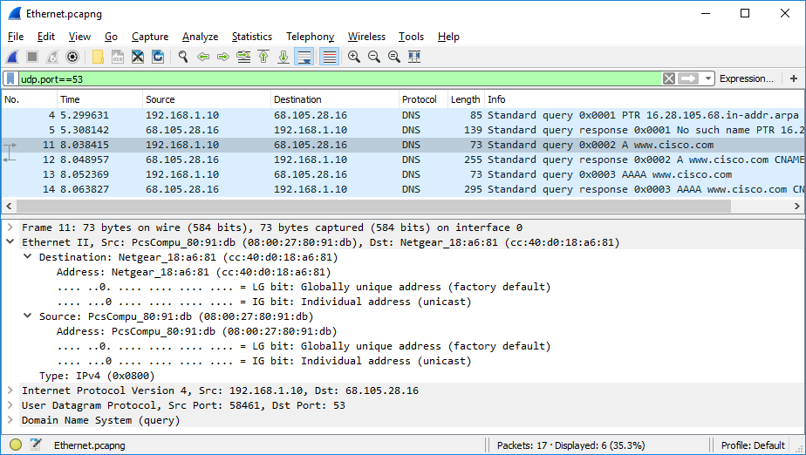

### Question:

What are the source and destination MAC addresses? Which network interfaces are these MAC addresses associated with?

The default gateway is connected to the destination MAC address and the PC's NIC to the source MAC address. If a local DNS server is operating, its MAC address would function as the destination MAC address.

* + 1. Expand **Internet Protocol Version 4**. Observe the source and destination IPv4 addresses.

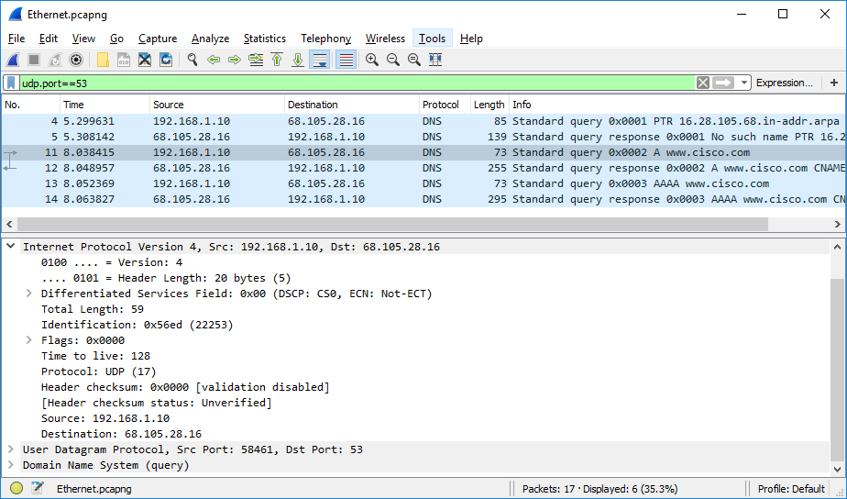

### Question:

What are the source and destination IP addresses? Which network interfaces are these IP addresses associated with?

The DNS server is connected to the destination IP address, while the source IP address is connected to the PC's NIC.

* + - * 1. Expand the **User Datagram Protocol**. Observe the source and destination ports.

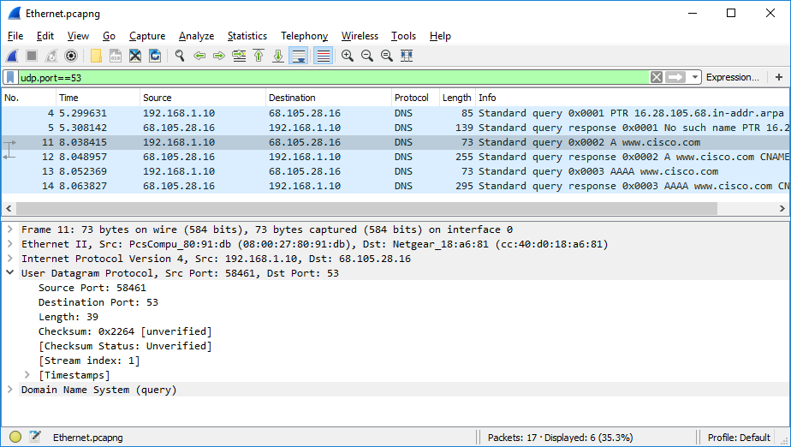

### Question:

What are the source and destination ports? What is the default DNS port number?

The destination port is 53(default DNS port number) and the source port is 58461.

* + - * 1. Open a Command Prompt and enter **arp –a** and **ipconfig /all** to record the MAC and IP addresses of the PC.

C:\Users\Student> **arp -a**

Interface: 192.168.1.10 --- 0x4

Internet Address Physical Address Type

192.168.1.1 cc-40-d0-18-a6-81 dynamic

192.168.1.122 b0-a7-37-46-70-bb dynamic

192.168.1.255 ff-ff-ff-ff-ff-ff static

224.0.0.22 01-00-5e-00-00-16 static

224.0.0.252 01-00-5e-00-00-fc static

239.255.255.250 01-00-5e-7f-ff-fa static

255.255.255.255 ff-ff-ff-ff-ff-ff static

C:\Users\Studuent> **ipconfig /all**

Windows IP Configuration

Host Name . . . . . . . . . . . . : DESKTOP

Primary Dns Suffix . . . . . . . :

Node Type . . . . . . . . . . . . : Hybrid

IP Routing Enabled. . . . . . . . : No

WINS Proxy Enabled. . . . . . . . : No

Ethernet adapter Ethernet:

Connection-specific DNS Suffix . :

Description . . . . . . . . . . . : Intel(R) PRO/1000 MT Desktop Adapter

Physical Address. . . . . . . . . : 08-00-27-80-91-DB

DHCP Enabled. . . . . . . . . . . : Yes

Autoconfiguration Enabled . . . . : Yes

Link-local IPv6 Address . . . . . : fe80::d829:6d18:e229:a705%4(Preferred)

IPv4 Address. . . . . . . . . . . : 192.168.1.10(Preferred)

Subnet Mask . . . . . . . . . . . : 255.255.255.0

Lease Obtained. . . . . . . . . . : Tuesday, August 20, 2019 5:39:51 PM

Lease Expires . . . . . . . . . . : Wednesday, August 21, 2019 5:39:50 PM

Default Gateway . . . . . . . . . : 192.168.1.1

DHCP Server . . . . . . . . . . . : 192.168.1.1

DHCPv6 IAID . . . . . . . . . . . : 50855975

DHCPv6 Client DUID. . . . . . . . : 00-01-00-01-24-21-BA-64-08-00-27-80-91-DB

DNS Servers . . . . . . . . . . . : 68.105.28.16

68.105.29.16

NetBIOS over Tcpip. . . . . . . . : Enabled

### Question:

Compare the MAC and IP addresses in the Wireshark results to the results from the **ipconfig /all** results. What is your observation?

The arp - a and ipconfig /all commands both list the same IP and MAC addresses as those recorded by Wireshark.

* + - * 1. Expand **Domain Name System (query**) in the Packet Details pane. Then expand the **Flags** and **Queries**.

Observe the results. The flag is set to do the query recursively to query for the IP address to www.cisco.com.

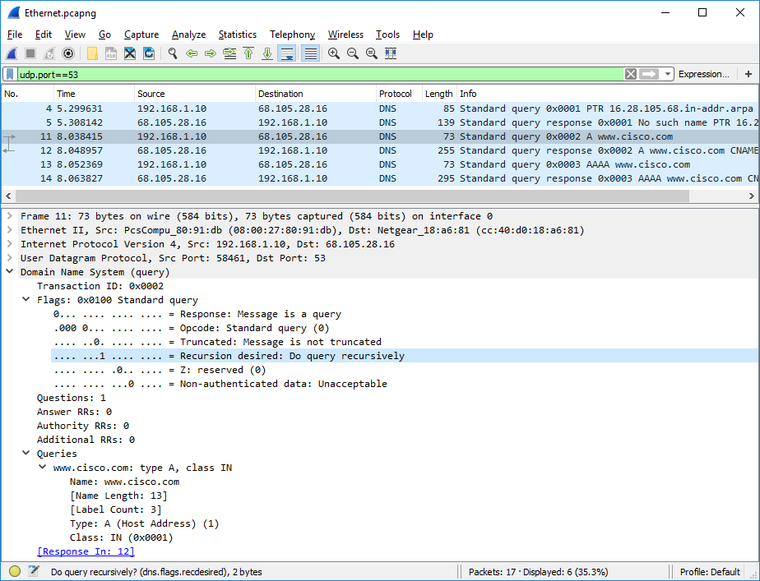

## Explore DNS Response Traffic

* + 1. Select the corresponding response DNS packet labeled **Standard query response 0x0002 A www.cisco.com**.

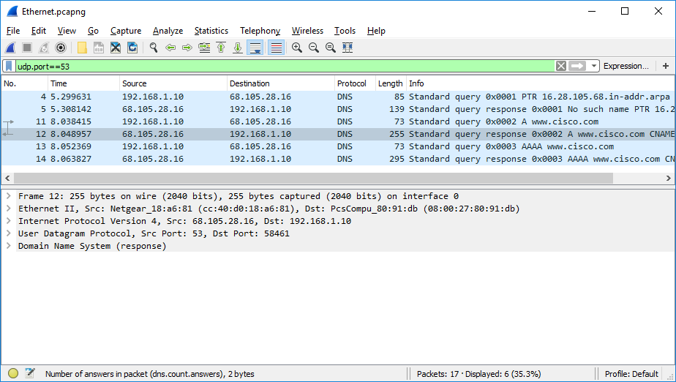

### Questions:

What are the source and destination MAC and IP addresses and port numbers? How do they compare to the addresses in the DNS query packets?

The query packet's source IP, MAC address, and port number are now the destination addresses. The source addresses in the inquiry packet are now the destination IP, MAC address, and port number.

* + 1. Expand **Domain Name System (response)**. Then expand the **Flags**, **Queries**, and **Answers**. Observe the results.

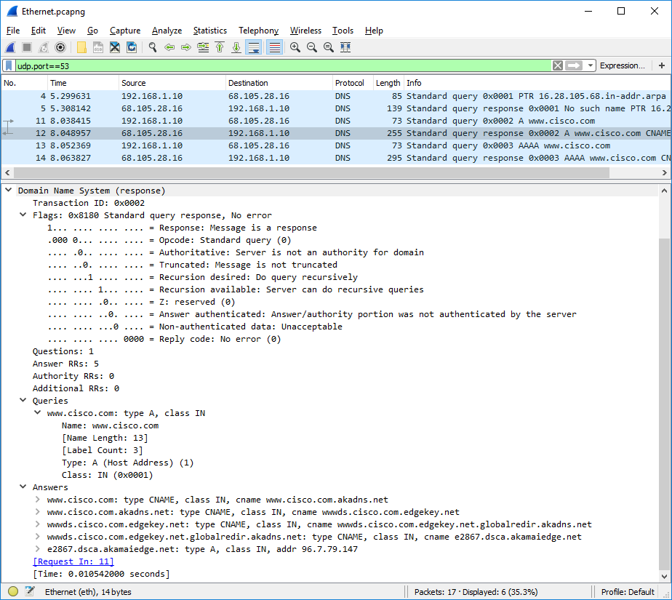

### Question:

Can the DNS server do recursive queries?

Yes, recursive queries are handled by the DNS.

* + 1. Observe the CNAME and A records in the answers details.

### Question:

How do the results compare to nslookup results?

The results from nslookup in the Command Prompt are same with the result in Wireshark.

# Reflection Question

* 1. From the Wireshark results, what else can you learn about the network when you remove the filter?

Without the filters, other packets, such as DHCP and ARP will appear in the results. We can discover information about other devices and their roles inside the LAN from these packets and the data they include.

* 1. How can an attacker use Wireshark to compromise your network security?

If the network traffic is not encrypted, an attacker on the LAN can use Wireshark to monitor it and obtain sensitive data in the packet details.

End of Document